Philip Trinh

SNHU/ CS-340

09/16/2023

3-1 Milestone: Database Indexing and Authentication

Part I: Importing and Indexing a Data Set

You have been asked to import a file for the Grazioso Salvare project. To do so, you must complete the following steps:

1. In Apporto, open the terminal window to access the Linux shell. Upload the Austin Animal Center (AAC) Outcomes data set into MongoDB by importing a CSV file using the appropriate MongoDB import tool. Use the database name “AAC” and collection name “animals”. Complete the import using the mongoimport tool and take screenshots of both the import command and its execution.

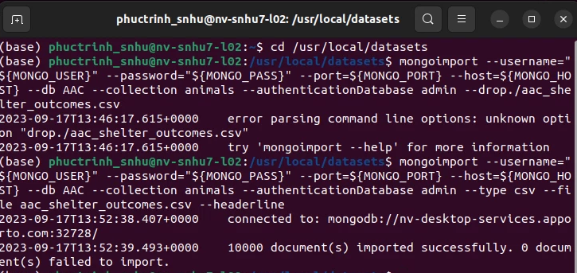Tip: How to import a CSV file is covered in the mongoimport documentation in the Module Three Resources. The Austin Animal Center (AAC) Outcomes data set has already been uploaded into Apporto in the /usr/local/datasets/ directory. The filename is “aac_shelter_outcomes.csv”.

2. After importing your data set, start up the mongo shell. Create a simple index on the key “breed”. Show an example query that will use this index and verify that the index will be used with the explain function. Take screenshots of your example query.

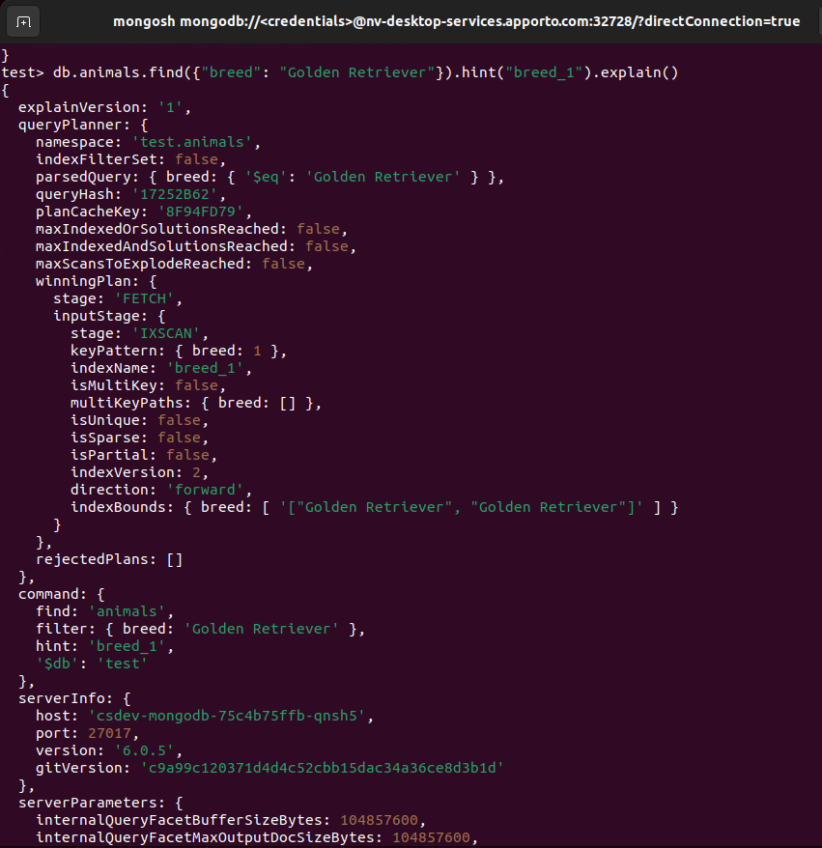

3. Create a compound index that will improve the performance of queries looking for breeds that have an “outcome_type” of “Transfer”. Show an example query that will use this compound index and confirm the index will be used with the explain function. Take screenshots of your example query.

**Part II: User Authentication**  
The client has asked you to comply with their security needs and **ensure user authentication to the database** by setting up both **administrator and user accounts**. Your administrator account has already been configured on your database in Apporto. So, you will only have to create a user account. To do so, follow the steps below.

1. **Create a new user account called “aacuser”** for the database AAC in the mongo shell. Refer to steps 6–7 of the MongoDB [Manual Enable Access Control](https://www.mongodb.com/docs/v6.0/tutorial/enable-authentication/) tutorial for help with this task. You will need to modify the commands so the account name is “aacuser.” Additional information with respect to user management may be found in the [User Management in MongoDB](https://learn.snhu.edu/content/enforced/1374834-CS-340-R1891-OL-TRAD-UG.23EW1/course_documents/CS%20340%20User%20Management%20in%20MongoDB.pdf?isCourseFile=true&_&d2lSessionVal=P8wcLdgYWQR1qU9280ic8jKTR&ou=1374834) document.  
    **Note:**You will need to create your user in the admin database, even though it will only have a role in the aac database. When you use the mongo shell (mongosh) to connect to the database with your user account, you will need to reset two environment variables to reflect the username and password you just created. (The MongoDB hostname and port will be pulled automatically from your environment variables.)  
    **Tip:**To make it easier to log in as your user, open up a second terminal session in your Linux environment. In this session, set the following environment variables:
2. MONGO_USER=aacuser
3. MONGO_PASS=The password you set when you created the aacuser account.

Once this is complete, you can run mongosh in that window as your new user.

IMPORTANT: Write down the password for the admin account and keep it somewhere safe. You will need to use this account later in the course.

1. **Take a screenshot** of your login process to MongoDB using the mongo shell. Be sure you can access MongoDB and list the databases using both the admin and aacuser accounts. This task will verify that your accounts are working. You should be able to include the login commands for both accounts in one screenshot, but if you cannot, include two screenshots to show both login commands.  
     
   When you have successfully attached to your MongoDB instance with mongosh, use the following command to verify that you have connected as a specific user:

db.runCommand({connectionStatus:1})

Include the results in your screenshot for each user.

